BCSE497J - PROJECT-I

EXPLAINABLE MULTIMODAL AI FOR EARLY DETECTION OF LEARNING ENGAGEMENT AND EMOTIONAL STATES IN CHILDREN USING EYE MOVEMENT

23BCE2012 | ILAKKIYA S
23BCE2064 | ADHVAITH N A
23BDS0006 | DON GEORGE

Under the Supervision of
Prof. DEEPIKA J
Assistant Professor Senior Grade 1
School of Computer Science and Engineering

B.Tech.
in
Computer Science and Engineering

School of Computer Science and Engineering



September 2026
ABSTRACT
Automatic recognition of student engagement from webcam video is difficult because the classifier is weak and because the observations are unreliable. A learner leans out of frame, rests a hand against the cheek, or the webcam loses focus, and the model is handed a face it cannot see - yet is asked to infer an affective state from it. Most pipelines respond by discarding such frames, which repairs image quality at the cost of destroying the temporal spacing any sequence model depends on.
This project builds a reliability-guided pipeline on the DAiSEE dataset that keeps every sampled frame and weights it instead. A Motion Reliability Score (MRS) is computed per frame from five observation-quality signals - blur, face visibility, head pose, eye and iris visibility, and motion consistency - none of which uses the engagement label. A frozen ImageNet-pretrained Vision Transformer encodes each aligned face crop into a 768-dimensional embedding; the reliability score scales that embedding and weights the temporal pooling, so unreliable frames contribute less without leaving the sequence. A Mamba selective state-space model then reads the weighted sequence across time. A parallel MediaPipe branch supplies 28 normalised geometric measurements and 52 ARKit blendshape activations per frame, fused with the deep branch before a four-class classifier.
Rather than fixing the five MRS weights at an arbitrary uniform value, the system learns to adaptively update the weights based on the training values from each epoch. The system initialises them at 0.20 each and learns them by gradient descent. The system reaches 38.75% validation accuracy against a 25% chance baseline (binomial p = 0.0046), with SHAP attribution identifying which facial feature groups the classifier relies on.

Keywords - Student Engagement Recognition, Vision Transformer, Mamba State-Space Model, Observation Reliability, MediaPipe Face Landmarks, DAiSEE, Explainable AI.

TABLE OF CONTENTS
Sl.No | Contents | Page No.
 | Abstract | i
1. | INTRODUCTION | 6
 | 1.1 Background | 6
 | 1.2 Motivations | 6
 | 1.3 Scope of the Project | 7
2. | PROJECT DESCRIPTION AND GOALS | 8
 | 2.1 Literature Review | 8
 | 2.2 Research Gap | 9
 | 2.3 Objectives | 10
 | 2.4 Problem Statement | 10
 | 2.5 Project Plan | 11
3. | TECHNICAL SPECIFICATION | 12
 | 3.1 Requirements | 12
 | 3.1.1 Functional | 12
 | 3.1.2 Non-Functional | 13
 | 3.2 Feasibility Study | 13
 | 3.2.1 Technical Feasibility | 13
 | 3.2.2 Economic Feasibility | 14
 | 3.2.3 Social Feasibility | 14
 | 3.3 System Specification | 15
 | 3.3.1 Hardware Specification | 15
 | 3.3.2 Software Specification | 15
4. | DESIGN APPROACH AND DETAILS | 16
 | 4.1 System Architecture | 16
 | 4.2 Design | 18
 | 4.2.1 Data Flow Diagram | 18
 | 4.2.2 Use Case Diagram | 19
 | 4.2.3 Class Diagram | 20
 | 4.2.4 Sequence Diagram | 21
5. | METHODOLOGY AND TESTING | 22
 | 5.1 Module Description | 22
 | 5.2 Testing | 23
6. | PROJECT DEMONSTRATION | 25
 | 6.1 Execution Sequence | 25
 | 6.2 Stage Outputs | 25
 | 6.3 Inference on a Single Clip | 25
 | 6.4 Explanation Output | 26
7. | RESULT AND DISCUSSION | 27
 | 7.1 Experimental Protocol | 27
 | 7.2 Three-Class Engagement Recognition | 27
 | 7.3 Binary Disengagement Detection | 28
 | 7.4 Ablation: Does Reliability Weighting Contribute? | 28
 | 7.5 Reliability Weight Stability | 29
 | 7.6 Explainability Results | 30
 | 7.7 Discussion | 31
8. | CONCLUSION | 32
 | 8.1 Summary of Work | 32
 | 8.2 Findings | 32
 | 8.3 Limitations | 32
 | 8.4 Future Work | 33
 | 8.5 Closing Remark | 33
9. | REFERENCES | 33
 | APPENDIX A - SAMPLE CODE | 36

1. INTRODUCTION

1.1 Background
Engagement is one of the strongest predictors of learning outcome, and its measurement has become urgent as instruction has moved online. In a physical classroom a teacher reads the room continuously and adapts; in a video-conferencing lecture with cameras in a grid, that feedback channel largely disappears. Automatic engagement recognition from webcam video aims to restore it.
DAiSEE is the standard public benchmark for this task. It contains 9,068 ten-second clips from 112 participants recorded in unconstrained settings - dormitories, laboratories, and offices - and each clip is annotated for four affective states: boredom, confusion, engagement, and frustration, each on a four-level intensity scale. This project uses the engagement label only.
What distinguishes engagement recognition from ordinary facial expression recognition is that engagement is a temporal construct. It is not visible in a single photograph; it appears in how attention is sustained, how gaze drifts, and how posture settles over seconds. Recognition therefore requires a model that reads a sequence rather than a frame. Recent state-space models such as Mamba make this affordable, offering sequence modelling at linear rather than quadratic cost in sequence length.

1.2 Motivation
The motivation for this project comes from a specific and under-addressed weakness in existing pipelines: they treat every frame as equally trustworthy. Real webcam recordings are not uniformly observable. A participant leans out of the frame, a hand covers the mouth, the autofocus hunts, the room darkens. When a frame is degraded, the visual evidence extracted from it is degraded too, and feeding it to a classifier with full weight injects noise directly into the prediction.
The conventional remedy is to gate: measure frame quality, and drop frames below a threshold. This is precisely the wrong remedy for a temporal model. Dropping frames changes the sequence length, closes the gaps, and destroys the uniform spacing that carries the temporal information in the first place. A heavily occluded clip and a clean clip arrive at the sequence model as different lengths, and the model has no way to know that one of them is missing time.
This project is motivated by a different treatment of the same signal. Reliability should be a soft weight applied in place, not a hard gate applied by deletion. Every sampled frame keeps its position and its timing; unreliable frames simply exert less influence. This preserves what the state-space model needs while still preventing poor observations from dominating the prediction.

1.3 Scope of the Project
The project covers the complete recognition pipeline from raw DAiSEE video to a four-class engagement prediction with an accompanying explanation. Within scope: uniform temporal sampling; face detection, alignment and cropping; computation of a five-component Motion Reliability Score; frozen Vision Transformer feature extraction; reliability-weighted temporal modelling with a Mamba selective state-space model; a parallel MediaPipe geometric and behavioural feature branch; feature fusion and classification; and SHAP-based attribution over the fused representation.
The engagement label is the sole prediction target. Boredom, confusion and frustration are present in the dataset but are not modelled. The Vision Transformer backbone is frozen throughout; end-to-end fine-tuning is deliberately deferred until the pipeline itself has been validated. Evaluation follows the official DAiSEE partition, and subject disjointness between splits is verified rather than assumed.
The project is explicitly not framed as an attempt to exceed the highest published DAiSEE accuracy. The research question is whether reliability-guided temporal modelling improves robust recognition while preserving temporal information, and the deliverable is a verified, reproducible pipeline with honestly reported measurements - including negative results where they occur.

2. PROJECT DESCRIPTION AND GOALS

2.1 Literature Review
The literature relevant to this project falls into five strands: the dataset and benchmark itself, temporal architectures for video understanding, state-space sequence models, facial feature extraction, and observation-quality assessment.

Dataset and benchmark
Gupta et al. [1] introduced DAiSEE as the first large-scale dataset for recognising affective states in e-learning from unconstrained webcam video, establishing the four-state, four-level annotation scheme used here. Their baselines with InceptionNet frame-level features, C3D and LRCN established the difficulty of the benchmark, particularly for the minority intensity levels. Subsequent work has repeatedly confirmed that DAiSEE engagement is severely imbalanced, with the two middle levels dominating, so accuracy alone is an inadequate metric [2], [3].

Temporal modelling for engagement
Because engagement unfolds over time, most competitive approaches model sequences rather than frames. Recurrent formulations using LSTM over per-frame CNN descriptors [4], 3D convolutional networks that learn spatiotemporal filters jointly [5], and more recently video transformers applying self-attention across frames [6] have all been applied. Attention-based approaches have consistently outperformed purely recurrent ones on this task, but self-attention costs quadratic time in sequence length, which limits how many frames can be processed.

State-space sequence models
Gu and Dao [7] introduced Mamba, a selective state-space model whose parameters are functions of the input, giving content-dependent propagation of information along the sequence at linear time and constant inference memory. Zhu et al. [8] adapted the idea to vision as Vision Mamba (Vim), using bidirectional Mamba blocks over image patch tokens as a backbone. It is important to distinguish these two uses: Vim is a spatial backbone over image tokens, whereas applying Mamba across a sequence of per-frame embeddings is temporal modelling. This project does the latter and names it accordingly. Mamba variants have already been applied to DAiSEE - a recent multi-scale contrastive framework reports Vision Mamba and VMamba baselines on the benchmark [9] - so this work does not claim novelty in applying Mamba to engagement recognition.

Facial feature extraction
Lugaresi et al. [10] describe MediaPipe, whose Face Mesh model regresses 468 three-dimensional facial landmarks in real time on commodity hardware, later extended with iris refinement to 478 points [11]. Kartynnik et al. [12] detail the underlying mesh regression. Beyond raw coordinates, the MediaPipe Face Landmarker additionally emits 52 ARKit-style blendshape activations - semantic descriptors such as eye blink, brow lowering and jaw opening - which are closely related in spirit to Facial Action Units [13] but are obtained without a separate AU model. Because raw landmark coordinates are dominated by face scale and position, normalised geometric derivatives such as eye aspect ratio [14] are conventionally preferred.

Observation quality and reliability
Image sharpness assessment has a long history; variance of the Laplacian [15] remains the standard no-reference estimator despite its known sensitivity to contrast, motivating perceptual alternatives [16]. In face analysis specifically, face image quality assessment has been shown to predict recognition error [17], establishing that a quality estimate can usefully modulate downstream confidence. Uncertainty-aware and confidence-weighted fusion is well established in multimodal learning [18], and attention-based frame weighting has been applied to video face recognition [19]. What is comparatively rare is a pipeline that computes an explicit, interpretable, label-independent per-frame reliability score and uses it to modulate a temporal sequence model without deleting frames - the gap this project addresses.

Explainability
Lundberg and Lee [20] introduced SHAP as a unified additive attribution framework with desirable theoretical properties, and it has become the standard tool for post-hoc feature attribution in affective computing pipelines. Attribution is used in this project to identify which facial feature groups the classifier relies upon, with the explicit caveat that attribution is not causation.

2.2 Research Gap
Three specific gaps emerge from the literature above.
- Reliability is used as a gate rather than a weight. Existing quality-aware pipelines typically threshold frame quality and discard frames that fall below it. For a temporal model this is self-defeating: removing frames alters the sequence length and destroys the uniform temporal spacing, so a degraded clip and a clean clip are no longer comparable inputs. No widely reported DAiSEE pipeline preserves the full temporal sequence while attenuating unreliable frames in place.
- Reliability weights are asserted, not learned. Where multi-factor quality scores are used, the relative importance of the factors is almost always fixed by hand - typically uniform. Whether blur, occlusion, head rotation and motion deserve equal influence for a given corpus and camera setup is an empirical question that is rarely asked, and never answered by optimisation.
- Reliability and behaviour are conflated. Head rotation and eye closure are frequently treated as evidence of disengagement. This confuses an observation-quality signal with the target construct: a turned head means the frontal appearance evidence is weaker, and a blink is normal behaviour rather than a bad observation. A reliability score that is contaminated by the label is no longer a reliability score.

2.3 Objectives
The project pursues the following specific, measurable objectives.
- O1. Construct a verified DAiSEE processing pipeline in which the official train/validation/test partition is used unchanged and subject disjointness between the three splits is measured and confirmed to be zero.
- O2. Define and implement a five-component Motion Reliability Score in [0,1] computed exclusively from observation-quality evidence, with every component verified to be finite and correctly bounded across the corpus.
- O3. Integrate the reliability score into a ViT-plus-Mamba temporal architecture such that the number and ordering of temporal positions is provably preserved - no frame is ever dropped.
- O4. Replace the arbitrary uniform weighting of the reliability components with weights learned by gradient descent from an initialisation of 0.20 each, and record their trajectory across training.
- O5. Fuse a MediaPipe geometric and behavioural branch with the deep temporal branch, with all dataset-dependent normalisation statistics fitted on the training split alone.
- O6. Evaluate with accuracy, weighted F1, macro F1, per-class precision/recall/F1 and a confusion matrix, benchmarked against explicit chance and majority-class baselines with statistical significance reported.
- O7. Produce SHAP attribution over the fused representation, grouped into interpretable facial feature families.

2.4 Problem Statement
Given a ten-second webcam video clip of a single learner, predict the annotated engagement intensity as one of four ordered levels - Very Low, Low, High, Very High - under the constraint that the observations within the clip vary in quality and that this variation must be accounted for without discarding temporal information.
Formally, let a clip yield T uniformly sampled frames. For each frame t a reliability score r_t in [0,1] is computed from observation-quality evidence alone, and a frozen Vision Transformer produces an embedding f_t. The system must learn a mapping from the reliability-weighted sequence to a four-class prediction such that the sequence length and the ordering of temporal positions are identical for every clip regardless of how degraded its frames are, and such that the reliability score is never derived from the engagement label.
The task is made harder by three properties of the data: the classes are severely imbalanced in the full DAiSEE release; adjacent intensity levels such as High and Very High are visually similar even to human annotators; and the same participant may appear in many clips, so a model can achieve apparently strong results by learning identity rather than engagement unless the splits are subject-disjoint.

2.5 Project Plan
The Project-I phase was organised into eleven tasks spanning approximately sixteen weeks, sequenced so that each verification gate precedes the work that depends on it. Dataset auditing precedes any preprocessing; the reliability score is designed and calibrated before it is integrated into the model; and the temporal encoder is verified against an independent reference implementation before training begins. Experimentation, explainability analysis and documentation occupy the final phase.
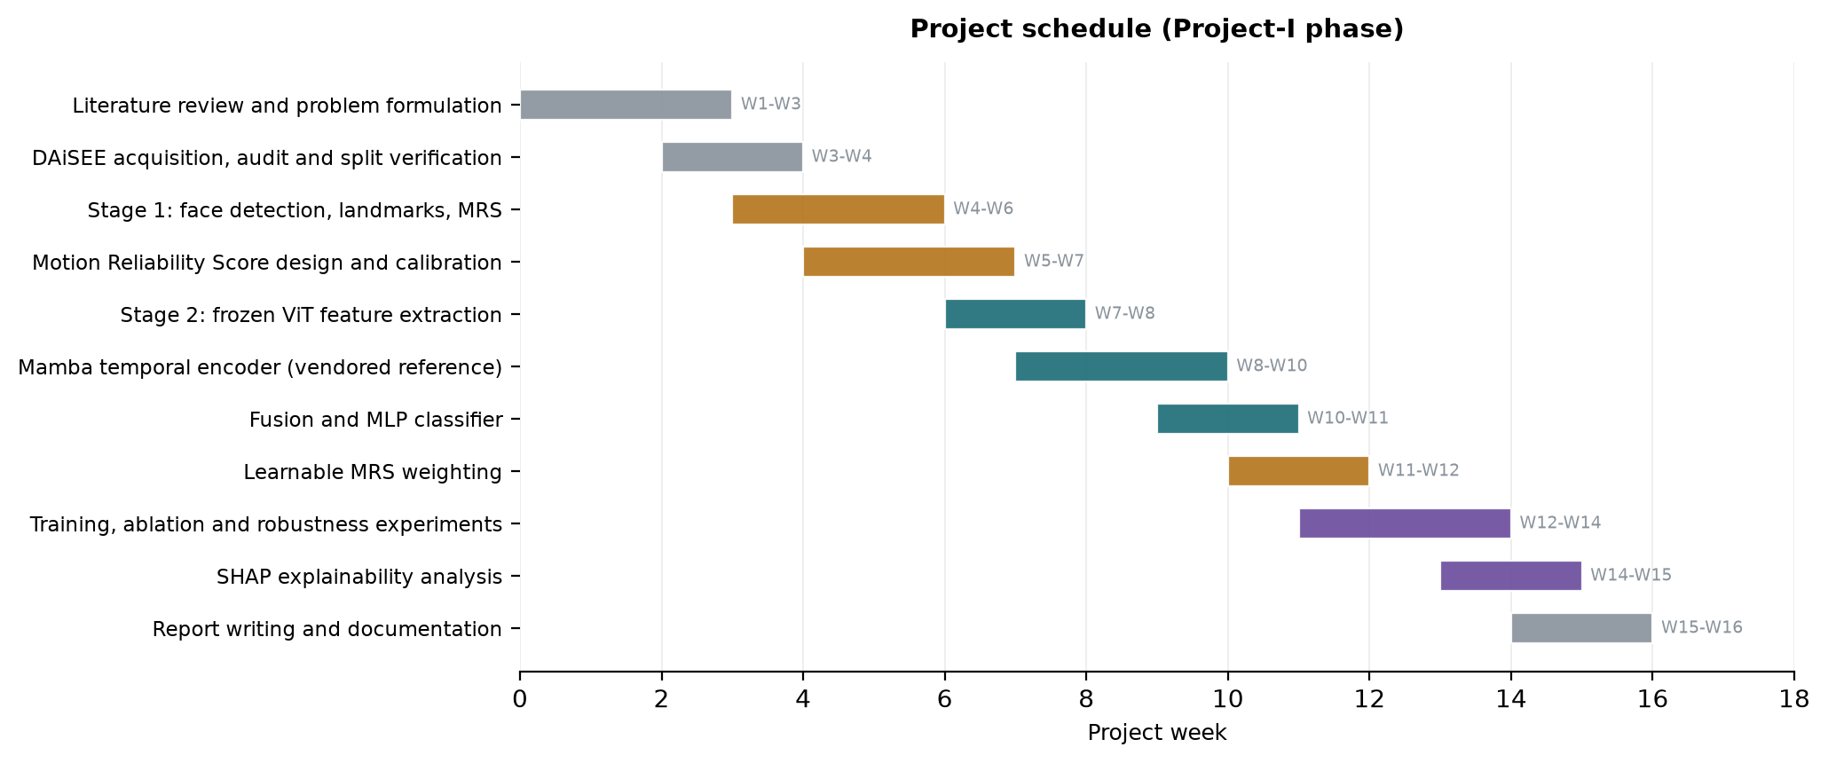
Fig. 2.1 Gantt chart of the Project-I schedule.

3. TECHNICAL SPECIFICATION

3.1 Requirements

3.1.1 Functional
The functional requirements below are grouped by pipeline stage and are stated as verifiable obligations of the system.
- Dataset ingestion and auditing (FR-1 to FR-5): the system shall locate the DAiSEE directory tree, parse the official label CSV files, join every video file to its label row, and report any label row without a matching file or any file without a label. It shall decode-probe each video and record frame rate, frame count, resolution and duration as measured rather than assumed. It shall derive the participant identifier for every clip and compute the pairwise subject overlap between train, validation and test, refusing to proceed if any overlap is non-zero.
- Temporal sampling (FR-6 to FR-8): the system shall select T frames per clip by uniform sampling, with T configurable over {8, 16, 32, 64}; it shall use deterministic sampling rather than random selection so that runs are reproducible; and it shall return exactly T frames for every clip, including clips shorter than T.
- Face processing (FR-9 to FR-12): the system shall detect the participant's face in each sampled frame, roll-align the crop using the detected eye keypoints, pad and resize it to the backbone's native input resolution, and record the detector confidence. Where no face is detected, it shall fall back through an explicit and recorded chain rather than dropping the frame, and shall mark the frame as unreliable.
- Reliability scoring (FR-13 to FR-17): the system shall compute five observation-quality components per frame - blur, face visibility, head pose, eye and iris visibility, and motion consistency - each bounded in [0,1]; it shall combine them into a single MRS value; it shall fit any dataset-dependent calibration on the training split only; and it shall guarantee that no engagement label participates in the computation.
- Feature extraction (FR-18 to FR-21): the system shall encode each aligned crop with a frozen pretrained Vision Transformer, discovering the embedding dimension from the loaded model rather than assuming it; and shall extract 478 facial landmarks, 52 blendshape activations and a head-pose matrix per frame, converting them into a fixed-width, scale-normalised feature vector.
- Temporal modelling and classification (FR-22 to FR-26): the system shall apply the reliability score to the frame embeddings without altering the number or order of temporal positions; shall model the resulting sequence with a Mamba selective state-space encoder; shall pool the sequence into a clip embedding; shall fuse it with the landmark branch after separate normalisation and projection; and shall output four raw class logits.
- Learning and evaluation (FR-27 to FR-32): the system shall initialise the five reliability weights at 0.20 each and update them by gradient descent during training, persisting the learned values in the checkpoint for use at validation and test time; shall select the reported checkpoint by validation macro F1 and never by test performance; and shall report accuracy, weighted F1, macro F1, per-class metrics and a confusion matrix, together with SHAP attribution over the fused representation.
- Caching and reproducibility (FR-33 to FR-36): the system shall cache expensive preprocessing keyed on a digest of every setting that affects the cached content, so that a stale cache cannot silently be reused; and shall record the exact package versions, device and configuration alongside every result artifact.

3.1.2 Non-Functional
- Correctness and verifiability: every pipeline stage shall be covered by an automated check that fails loudly rather than degrading silently. The temporal encoder in particular shall be verified for causality and for numerical agreement with an independently written reference implementation of the underlying recurrence.
- Data integrity and leakage prevention: no statistic used at inference time - reliability calibration, feature scaler, or class weights - shall be fitted on validation or test data, and this shall be enforced structurally rather than by convention.
- Performance: preprocessing of the 216-clip development corpus shall complete in under five minutes on a single consumer GPU, and a training epoch on cached features shall complete in under two seconds so that experiments can be iterated rapidly.
- Scalability: the architecture shall scale to the full 9,068-clip DAiSEE release by configuration change alone, with preprocessing split so that changing the visual backbone does not require repeating the CPU-bound landmark extraction.
- Reproducibility: all randomness shall be seeded, and any reported figure shall be traceable to a committed artifact file rather than to a transcript.
- Privacy and licensing: the DAiSEE video, the derived face crops and the extracted biometric landmark data shall never be committed to version control, and per-clip ground-truth labels shall not be redistributed.
- Maintainability: sampling, face processing, reliability scoring, encoding, temporal modelling, fusion and evaluation shall live in separate modules with no hard-coded dataset paths, tensor dimensions or model constants.

3.2 Feasibility Study

3.2.1 Technical Feasibility
- All three pretrained models required are publicly available and free to obtain: the ImageNet-pretrained ViT-B/16 backbone through the timm library, and the MediaPipe BlazeFace detector (230 KB) and Face Landmarker (3.76 MB) bundles from Google's published model URLs. No custom pretraining is required.
- Freezing the Vision Transformer reduces the trainable parameter count from roughly 87 million to 1.37 million, which trains comfortably within the 6 GB of memory available on the development GPU.
- A significant technical risk was identified and resolved during implementation. The official mamba-ssm package is distributed as source only and its build requires the CUDA Toolkit compiler, which was not available on the development machine; installation failed. Rather than substitute a different architecture, the project vendors the official reference (non-fused) implementation from the Mamba repository, which computes the same function without compilation. The trade-off is speed, not correctness, and the active backend is recorded in every result artifact.
- Splitting preprocessing into a backbone-independent CPU stage and a GPU feature-extraction stage keeps the pipeline affordable: changing the visual backbone costs only the second stage, which is roughly 27 seconds for the development corpus.

3.2.2 Economic Feasibility
- Software cost is zero. PyTorch, timm, MediaPipe, OpenCV, scikit-learn and SHAP are all open-source, and the pretrained weights are released for research use.
- Hardware cost is confined to a single consumer laptop GPU already available to the team; no cloud compute, paid API or annotation budget is required.
- DAiSEE is released free of charge for research subject to a registration agreement, so there is no data acquisition cost.
- The dominant cost is student time. Because features are cached, a full training run completes in under a minute, which makes the experimental iteration cost negligible relative to development effort.

3.2.3 Social Feasibility
- Engagement recognition applied to students is ethically sensitive. The system is positioned as an aggregate research instrument, not as a surveillance or grading tool, and no per-student decision-making is proposed.
- DAiSEE annotations are third-party judgements of observable affect. They should not be interpreted as objective measurements of a learner's internal mental state, and the report is explicit on this point.
- The dataset is licence-restricted video of identifiable people. The project therefore excludes the video, the derived face crops and the extracted landmark data from version control entirely, and treats per-clip label values as non-redistributable.
- Deployment beyond research would require informed consent, institutional ethics review, and a demonstrated absence of demographic performance disparity - none of which is claimed here.

3.3 System Specification

3.3.1 Hardware Specification
Table 3.1 Hardware specification.
Component | Development configuration (used) | Recommended for full DAiSEE
Processor | x86-64, 8 logical cores | 12+ cores (MediaPipe is CPU-bound)
Memory (RAM) | 16 GB | 32 GB
Storage | 60 GB free (SSD) | 250 GB SSD (15 GB dataset + caches)
Graphics Processing Unit | NVIDIA GeForce RTX 3060 Laptop, 6 GB, compute 8.6 | NVIDIA RTX 3090 / A4000, 12-16 GB
Display | 1920 x 1080 | 1920 x 1080 or higher

3.3.2 Software Specification
Table 3.2 Software specification (versions as verified on the development machine).
Layer | Software | Version
Operating system | Windows 11 Home (64-bit) | 10.0.26200
Language | Python | 3.13.3
Deep learning | PyTorch / torchvision | 2.11.0+cu128 / 0.26.0+cu128
GPU runtime | CUDA (bundled with PyTorch wheel) | 12.8
Vision backbones | timm (PyTorch Image Models) | 1.0.29
Transformer hub | transformers | 5.16.1
Facial analysis | MediaPipe Tasks (Face Detector, Face Landmarker) | 1.0.1
Image processing | OpenCV | 5.0.0
Sequence model | Vendored Mamba reference (state-spaces/mamba) | pytorch_reference
Numerics | NumPy | 2.5.2
Metrics | scikit-learn | 1.9.0
Explainability | SHAP | 0.52.0
Plotting | Matplotlib | 3.11.1
Testing | pytest | 9.1.1

4. DESIGN APPROACH AND DETAILS

4.1 System Architecture
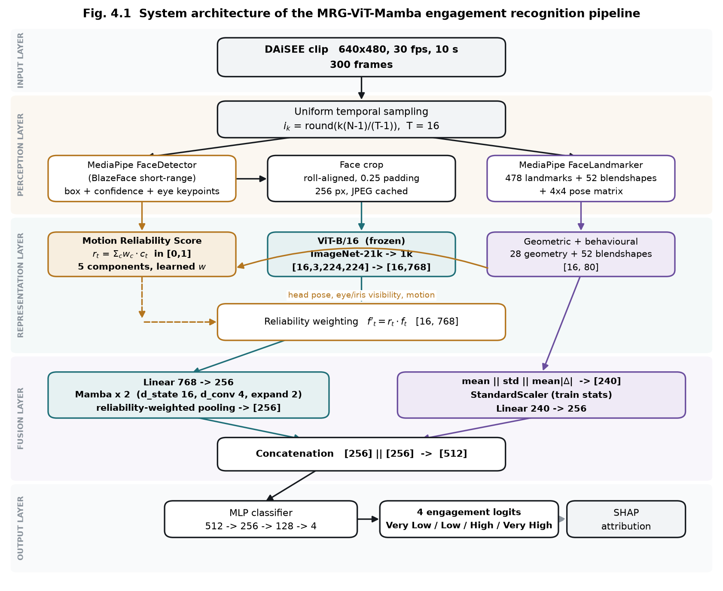
Fig. 4.1 System architecture of the MRG-ViT-Mamba engagement recognition pipeline.
The architecture is organised into five layers. The input layer accepts a ten-second DAiSEE clip at 640 x 480 and 30 frames per second, from which the perception layer draws T = 16 uniformly spaced frames using the index rule i_k = round(k(N-1)/(T-1)). Sampling is deterministic so that a rerun reproduces the same frames exactly.
The perception layer applies two pretrained MediaPipe models to every sampled frame. The BlazeFace short-range detector returns a bounding box, a confidence score and six facial keypoints; the two eye keypoints are used to roll-align the crop before it is padded by 25 percent and resized. The Face Landmarker independently returns 478 three-dimensional landmarks including ten iris points, 52 ARKit blendshape activations, and a 4 x 4 facial transformation matrix from which yaw, pitch and roll are decomposed.
The representation layer contains the three parallel computations that give the architecture its character. The Motion Reliability Score combines five observation-quality signals into a single value per frame. The frozen ViT-B/16 encodes each aligned crop into a 768-dimensional embedding, batched as [B,T,C,H,W] reshaped to [B*T,C,H,W] and restored to [B,T,768] in a single call rather than a per-frame loop. The landmark branch converts the raw mesh into 28 scale-normalised geometric measurements which, with the 52 blendshapes, give an 80-dimensional descriptor per frame. Reliability weighting is then applied as f'_t = r_t * f_t, an operation which by construction preserves the tensor shape and every temporal position.
The fusion layer projects the reliability-weighted sequence from 768 to 256 dimensions and passes it through two Mamba blocks. Each block applies RMSNorm, an input projection, a causal depthwise convolution, a SiLU gate and the selective scan, with a residual connection. The sequence is aggregated by reliability-weighted pooling, D = sum_t r_t h_t / sum_t r_t, which is where the reliability signal most strongly determines the clip representation. In parallel the per-frame landmark descriptors are aggregated across time by concatenating their mean, standard deviation and mean absolute temporal difference, giving a 240-dimensional clip vector which is standardised using training-split statistics and projected to 256 dimensions. The two 256-dimensional branch outputs are concatenated to 512.
The output layer is a multilayer perceptron of 512 to 256 to 128 to 4 with GELU activations and dropout, producing four raw logits trained with class-weighted cross-entropy. SHAP attribution is computed over the representation entering fusion, where the landmark half still has named dimensions and can therefore be grouped into interpretable facial families.

Table 4.1 Parameter budget of the assembled model.
Module | Detail | Parameters | Trained
ViT-B/16 backbone | frozen, preprocessing stage | 85,798,656 | No
Temporal input projection | Linear 768 -> 256 | 196,864 | Yes
Mamba blocks | 2 blocks, d_inner 512, d_state 16 | 876,032 | Yes
Final RMSNorm | 256 | 256 | Yes
Deep branch projection | LayerNorm + Linear 256 -> 256 | 66,304 | Yes
Landmark branch projection | Scaler + Linear 240 -> 256 | 61,696 | Yes
Learnable MRS weights | softmax over 5 components | 5 | Yes
MLP classifier | 512 -> 256 -> 128 -> 4 | 164,740 | Yes
Trainable total |  | 1,365,897
Whole pipeline |  | 87,164,553

4.2 Design

4.2.1 Data Flow Diagram
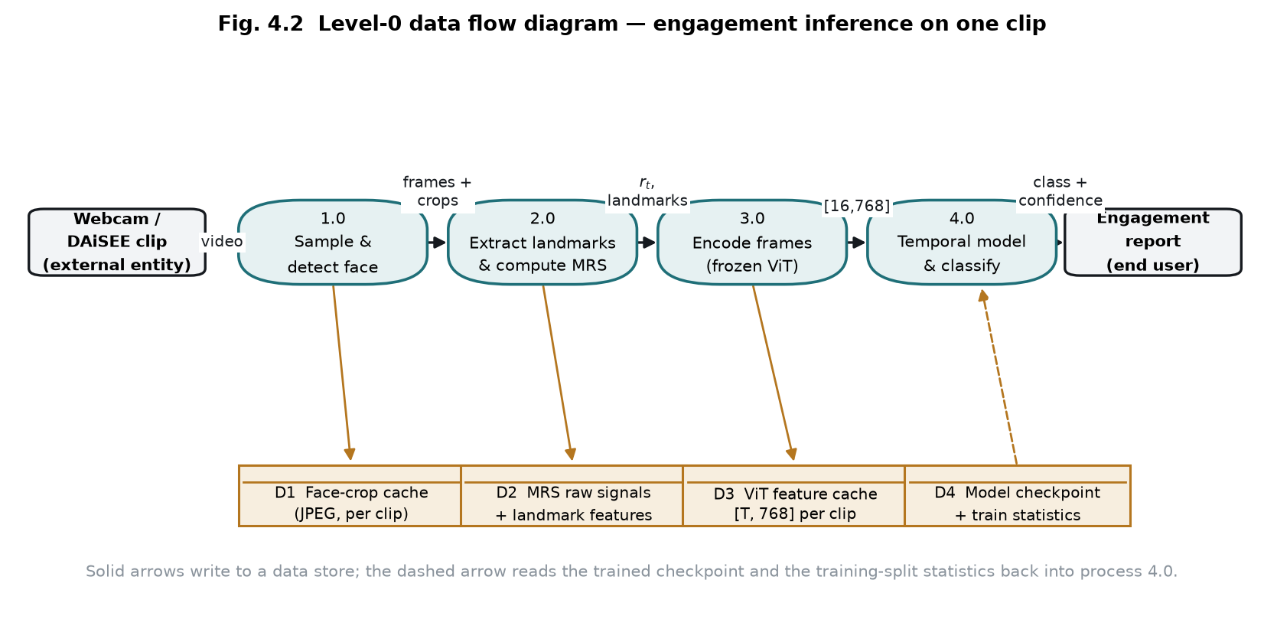
Fig. 4.2 Level-0 data flow diagram for engagement inference on a single clip.
The diagram traces one clip through the system. The clip enters process 1.0, which samples sixteen frames and detects, aligns and crops the face, writing the crops to data store D1. Process 2.0 extracts landmarks and blendshapes and computes the five raw reliability signals, which are written to D2 in their uncalibrated form. Storing the raw signals rather than a finished score is a deliberate design decision: it allows the reliability calibration to be refitted, or the component weights to be changed, without decoding a single video again. Process 3.0 encodes the cached crops with the frozen Vision Transformer, writing the resulting per-frame embeddings to D3. Process 4.0 reads the cached embeddings, the reliability signals and the landmark descriptors, applies the reliability weighting, runs the Mamba temporal encoder and the fusion classifier, and emits the predicted engagement level with its confidence. The dashed edge indicates that process 4.0 also reads the trained checkpoint and the training-split normalisation statistics from D4.

4.2.2 Use Case Diagram
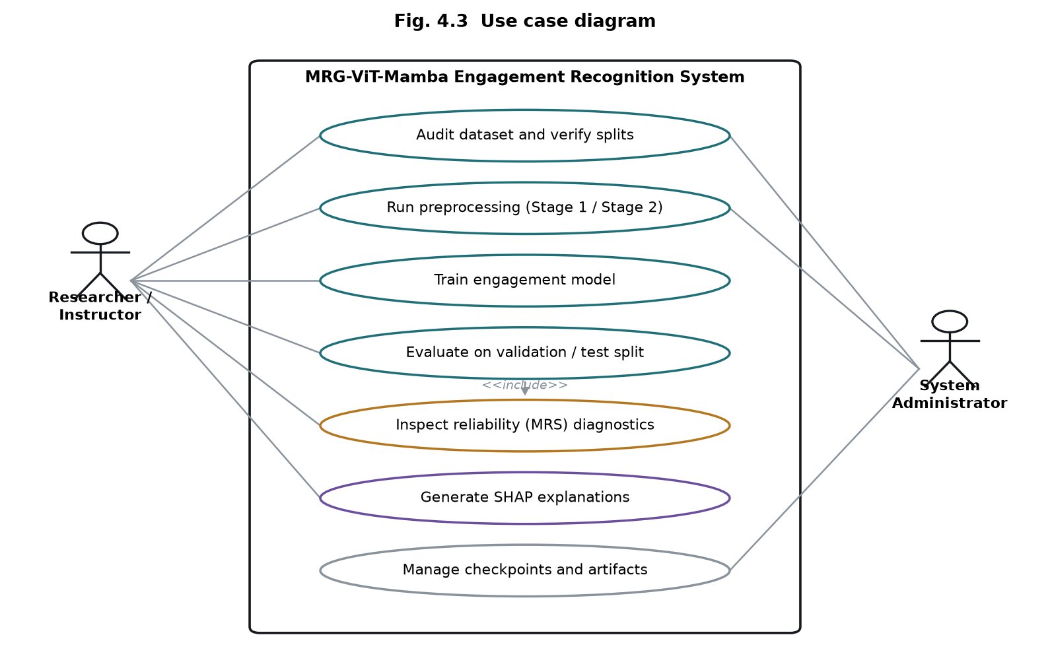
Fig. 4.3 Use case diagram.
Two actors interact with the system. The researcher or instructor audits the dataset and verifies the splits, runs the two preprocessing stages, trains the model, evaluates it on the validation and test partitions, inspects the reliability diagnostics, and generates SHAP explanations. Evaluation includes inspection of the reliability diagnostics, since interpreting a per-class score requires knowing how observable the underlying clips were. The system administrator role covers checkpoint and artifact management along with the preprocessing and audit operations, which are infrastructural rather than experimental.
4.2.3 Class Diagram
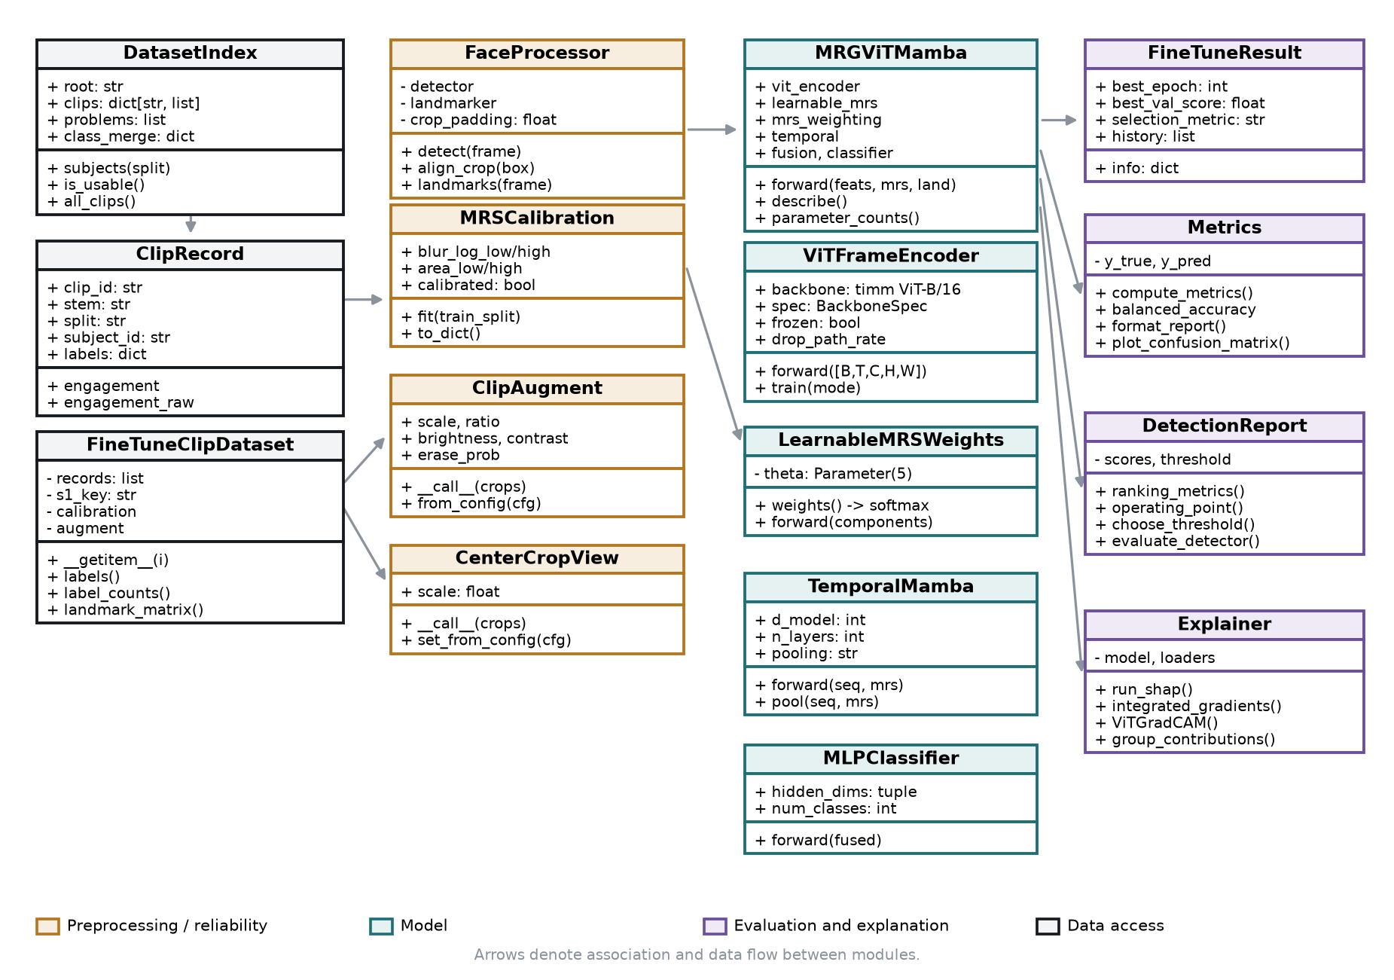
Fig. 4.4 Class diagram of the implemented system.
The class diagram groups the implementation into four collaborating layers. Data access is handled by DatasetIndex, which discovers the DAiSEE tree and joins each ClipRecord to its label row, and by FineTuneClipDataset, which serves cached crops and landmark features to the training loop. The preprocessing layer contains FaceProcessor, which wraps the two MediaPipe models, MRSCalibration, which holds the percentile bounds fitted on the training split, and the two augmentation classes: ClipAugment for training and CenterCropView for deterministic test-time views. The model layer is assembled by MRGViTMamba from ViTFrameEncoder, LearnableMRSWeights, TemporalMamba and MLPClassifier. The evaluation layer consumes the trained model: FineTuneResult carries the selected checkpoint and history, Metrics and DetectionReport compute the reported figures and their baselines, and Explainer produces the attribution analyses.

4.2.4 Sequence Diagram
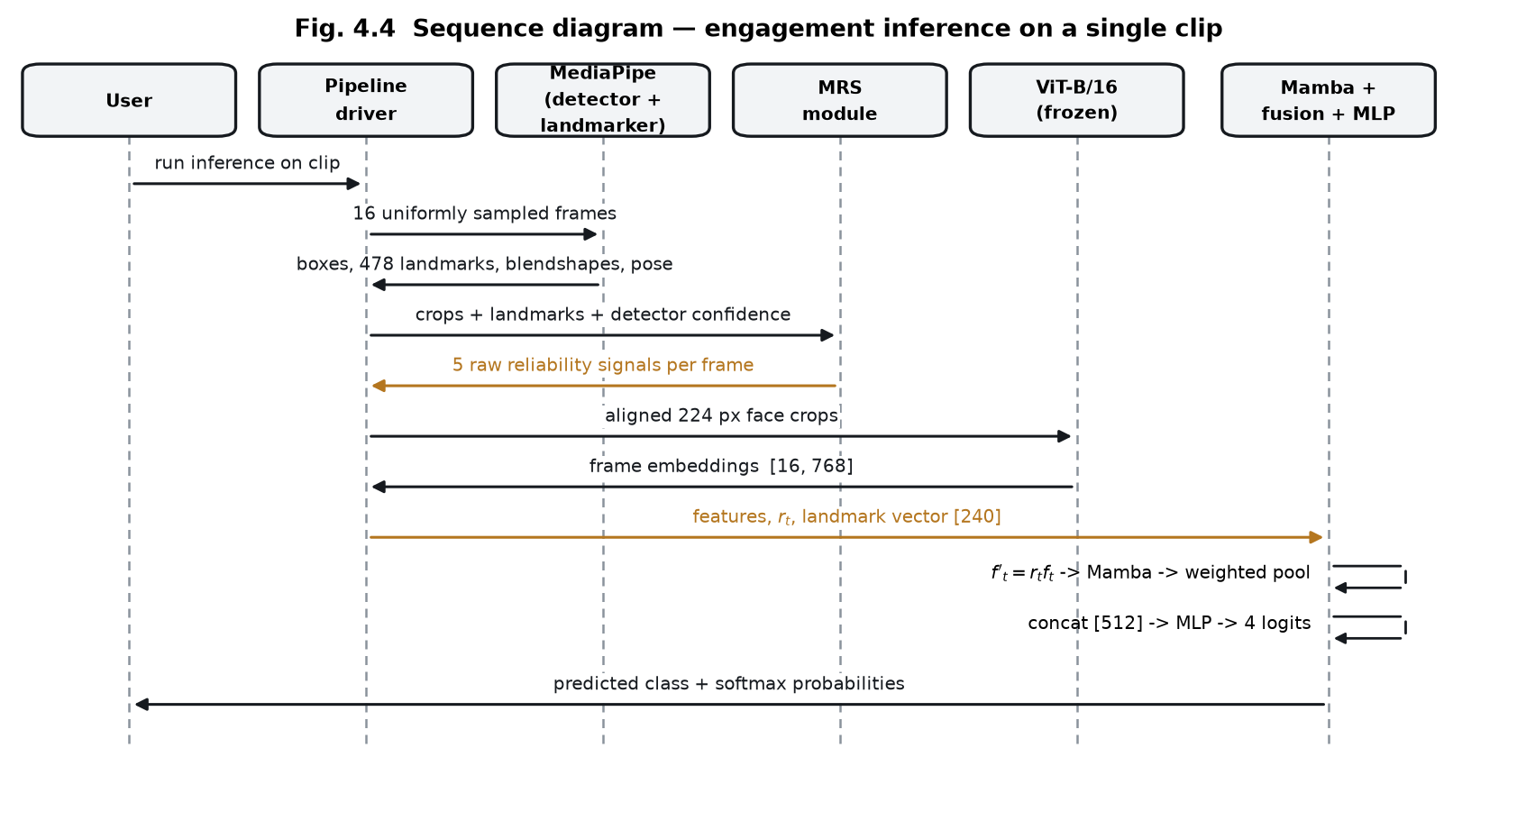
Fig. 4.5 Sequence diagram for engagement inference on a single clip.
The sequence shows the order of interactions during inference. The pipeline driver samples sixteen frames and passes them to MediaPipe, which returns detector boxes, landmarks, blendshapes and pose matrices. These, together with the aligned crops and the detector confidence, are passed to the reliability module, which returns the five raw signals per frame. The crops are then encoded by the frozen Vision Transformer into a [16, 768] tensor. The temporal and fusion stage receives the embeddings, the reliability vector and the landmark descriptor, applies the weighting, runs the Mamba encoder and reliability-weighted pooling, concatenates the two branches and produces four logits, which are returned as a predicted class with softmax probabilities.

5. METHODOLOGY AND TESTING
5.1 Module Description
The system is divided into nine modules with narrow interfaces, so that a change to one is verifiable in isolation. The division follows the data as it moves from raw video to an explained prediction.
5.1.1 Dataset indexing and auditing
The indexing module walks the DAiSEE directory tree, parses the four official label CSV files and joins each video to its label row. It does not assume the shipped layout is clean: the label files carry a trailing space in the final header, the ClipID column includes the file extension, and for at least one clip the CSV and the directory tree disagree on that extension, so matching falls back to the file stem. The module derives the subject identifier from the directory one level below the split directory, which is what makes subject disjointness checkable. On the full release it indexes 5,357 training, 1,429 validation and 1,784 test clips across 69, 19 and 21 subjects respectively, and reports zero subject overlap between any pair of splits.
5.1.2 Stage 1 preprocessing
Stage 1 samples T frames uniformly from each clip, detects and roll-aligns the face with MediaPipe BlazeFace, extracts 478 landmarks, 52 blendshape coefficients and a 4x4 head-pose matrix with MediaPipe FaceLandmarker, and writes the aligned JPEG crops together with the five raw reliability signals to a compressed cache. The cache key is a digest of every setting that affects its contents, so changing the frame count or the crop padding produces a new cache rather than silently reusing stale data. Measured on the full release at T = 16, this stage processes 8,570 clips in roughly fifteen minutes across six parallel shards and occupies 1.3 GB on disk.
5.1.3 Motion Reliability Score
The reliability module converts the five cached raw signals into calibrated components in [0,1]: blur from the variance of the Laplacian, face visibility from the detected box area and detector confidence, head pose from the yaw and pitch deviation from frontal, eye visibility from the landmark mesh, and motion consistency from frame-to-frame landmark displacement. Blur and face area are calibrated against percentiles measured on the training split only, so no statistic used at inference is fitted on held-out data. The components are combined into a single per-frame scalar by a weight vector obtained as the softmax of five learned parameters.
5.1.4 Spatial encoder
Each aligned crop is encoded by a ViT-B/16 backbone pretrained on ImageNet, producing a 768-dimensional embedding per frame. The encoder flattens the [B, T, C, H, W] batch to [B x T, C, H, W] once and processes it in chunks, rather than looping over frames in Python. In the final configuration the last four of twelve transformer blocks and the final normalisation layer are trainable, which is 28.4 million of the backbone's 85.8 million parameters; the remainder is frozen.
5.1.5 Reliability-weighted temporal encoder
The reliability score enters the network twice. Each frame embedding is scaled by its own reliability before the temporal encoder sees it, and the temporal pooling that follows is a reliability-weighted average rather than a mean. Critically, neither operation removes a frame: the number and ordering of temporal positions is preserved, so the state-space model still receives a regularly sampled sequence. The temporal encoder is a two-layer Mamba selective state-space model at d_model = 256. Because the official CUDA kernel requires a compiler toolchain that is not available on the development machine, the vendored reference implementation is used; it is mathematically equivalent and slower, and the active backend is recorded in every artifact.
5.1.6 Landmark branch and fusion
A parallel branch aggregates the per-frame landmark geometry into a 240-dimensional clip descriptor by taking the mean, standard deviation and mean absolute temporal difference of each named feature. The standardiser for this branch is fitted on the training split alone. The two branches are projected to 256 dimensions each and concatenated, giving a 512-dimensional fused representation that feeds the classifier.
5.1.7 Classifier and loss
The classifier is a multilayer perceptron with GELU activations and dropout. Class imbalance is addressed at two independent points: how often each class is drawn, through a weighted sampler, and how much each mistake costs, through class-weighted loss. The two are deliberately not stacked, because together they multiply: on the binary task the sampler alone lifts the minority class from 4.6% to 27.8% of draws, and adding effective-number loss weights on top would move the effective prior to roughly 81% when the true rate is 4.6%.
5.1.8 Evaluation
The evaluation module computes accuracy, balanced accuracy, macro and weighted F1, per-class precision, recall and F1, and the confusion matrix, and prints each next to the baseline that applies to it. For the binary task it adds ROC-AUC and average precision, and selects an operating threshold on the validation split which is then applied unchanged to test. The test split is read exactly once per run, after the checkpoint has been chosen.
5.1.9 Explainability
Four complementary methods are implemented: SHAP attribution over the fused representation grouped into named facial feature families, integrated gradients from an all-zero baseline to separate the deep and landmark branch contributions, Grad-CAM over the Vision Transformer to show where on the face the model looked, and a per-frame reliability trace showing which frames the temporal pooling weighted most.
5.2 Testing
The project is covered by an automated suite of 169 tests. The suite is not written to confirm that the code runs; it is written so that the specific failures this kind of pipeline produces silently will fail loudly instead. Table 5.1 groups the tests by what they protect.
Table 5.1 Automated test coverage by concern.
Concern | What the tests pin | Tests
Temporal integrity | Reliability weighting changes values but never the number or order of temporal positions | 18
Leakage prevention | Calibration, feature scaler and class weights are fitted on the training split only; splits stay subject-disjoint | 14
Class merging | The merge partitions every class exactly once, is applied identically to all three splits, and preserves the original label | 24
Reliability weights | Softmax weights cannot collapse onto one component; a real signal still moves them; noise alone leaves them uniform | 12
Sampling | No clip is discarded, epoch length is unchanged, rare classes are lifted, repetition is capped | 10
Prior correction | The correction is identity when priors agree, and never derives its shift from the evaluated split | 22
Detection metrics | A constant predictor scores 0.95 accuracy and detects nothing; a better detector may score lower accuracy | 13
Caching and resumption | Cache keys change when inputs change; interrupted runs resume without repeating or skipping an epoch | 26
Numerical and shape contracts | Dimensions are discovered rather than assumed; scores stay in range; metrics match hand calculation | 30

Two tests deserve specific mention because each encodes a defect that was found in a working system rather than imagined. The first drives the learned reliability weights under constant one-sided gradient pressure for the number of steps a full run takes, and asserts that they remain bounded; without the prior that this test protects, they collapse. The second asserts that a detector with genuine signal may report lower accuracy than a constant predictor, which prevents a future change from quietly reinstating accuracy as the headline metric on a 95/5 split.

6. PROJECT DEMONSTRATION
This chapter walks through one complete execution of the system on the full DAiSEE release, from raw video to an explained prediction, and lists the artifacts each stage leaves behind. Every path and figure quoted here was produced by the run described.
6.1 Execution sequence
The pipeline is driven from the command line. The dataset location, the cache location and the checkpoint location are supplied through environment variables so that the same committed configuration runs on a machine whose storage layout differs, without editing a tracked file.
export DAISEE_ROOT=D:/DAiSEE
export MRG_CACHE_DIR=C:/mrg_run/cache
export MRG_CHECKPOINT_DIR=C:/mrg_run/checkpoints

python scripts/audit_dataset.py --config configs/config_binary_full.yaml
python scripts/run_preprocessing.py --config configs/config_binary_full.yaml --stage 1
python scripts/fit_mrs_stats.py --config configs/config_binary_full.yaml
python scripts/run_finetune.py --config configs/config_binary_full.yaml \
--run-name fullbin --workers 2 --tta
python scripts/run_shap_finetuned.py --config configs/config_binary_full.yaml \
--run fullbin --split test
python scripts/explain_finetuned.py --config configs/config_binary_full.yaml \
--run fullbin
6.2 Stage outputs
Table 6.1 records what each stage produced in the demonstrated run, with the wall-clock cost measured on the development machine described in section 3.3.
Table 6.1 Pipeline stages, outputs and measured cost.
Stage | Output | Cost
Dataset audit | 8,570 clips indexed, zero subject overlap, 497 videos without label rows excluded | < 1 min
Stage 1 preprocessing | Aligned face crops and reliability signals for 8,570 clips, 1.3 GB cache | 15 min
MRS calibration | Blur and face-area percentiles fitted on 5,357 training clips | 1 min
Training | 7 epochs at 8.6 min/epoch, best checkpoint at epoch 0, early stopping on patience | 60 min
Evaluation | Train, validation and test scored once with three-view test-time augmentation | 20 min
SHAP attribution | 512 test clips explained against 512 background clips | 12 min
Worked examples | Three clips from three participants with Grad-CAM, reliability traces and branch attribution | 4 min

6.3 Inference on a single clip
For a single ten-second clip the system samples sixteen frames, detects and aligns the face in each, computes the five reliability components, encodes each crop through the Vision Transformer, scales each embedding by its reliability, passes the sequence through the Mamba encoder, pools it with the same reliability weights, fuses the result with the landmark descriptor and produces a class probability. The worked example produced by the demonstration shows a clip correctly identified as not engaged with probability 0.98, in which the mean frame reliability was 0.48 and the most heavily weighted frames were 0, 8 and 13.
6.4 Explanation output
The demonstration produces two population-level explanation figures and one set of per-clip figures. Figure 6.1 shows the share of attribution carried by each facial feature family across 512 test clips; figure 6.2 shows the resulting confusion matrix on the full test split.
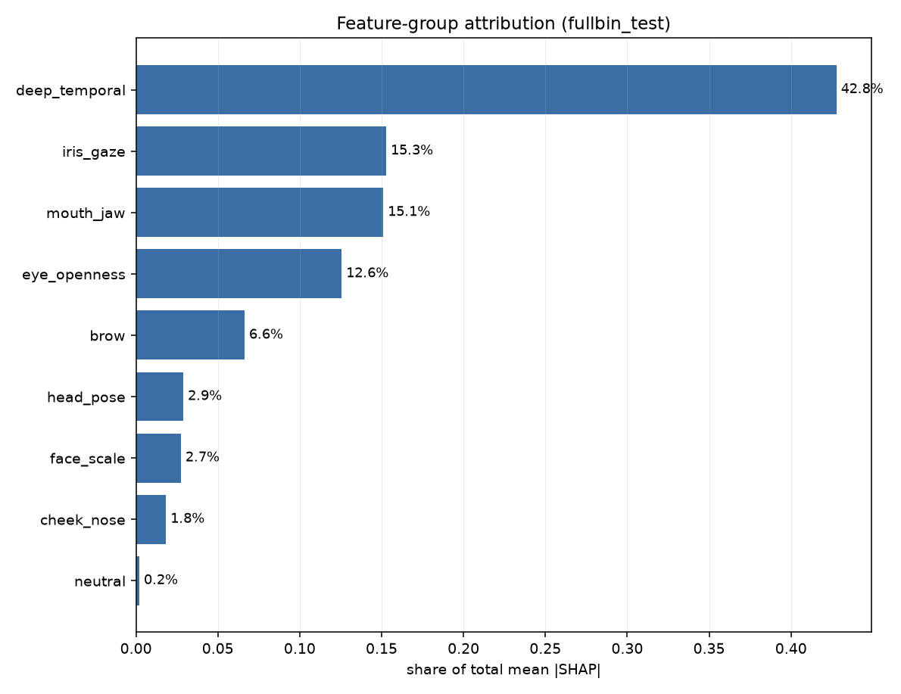
Fig. 6.1 SHAP attribution by facial feature family, 512 test clips.
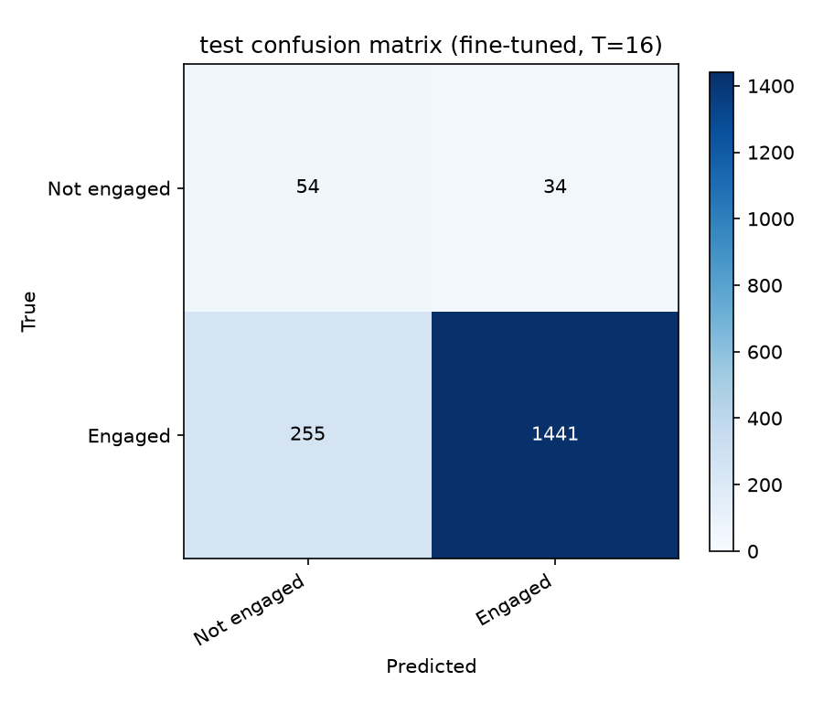
Fig. 6.2 Confusion matrix on the full DAiSEE test split, 1,784 clips.
The per-clip figures additionally contain the participant's face and are therefore written to a version-control-excluded directory and are not reproduced in this report, in keeping with the licence conditions described in section 3.2.3.

7. RESULT AND DISCUSSION
This chapter reports what the system achieved, what it did not, and what the controlled comparison says about the mechanism the project proposes. Every figure is accompanied by the baseline that applies to it, because on DAiSEE the class distribution makes several metrics uninformative without one.
7.1 Experimental protocol
The official DAiSEE partition is used unchanged. Subject disjointness between the three splits was verified programmatically and holds exactly. The checkpoint is selected on validation balanced accuracy; the test split is read once per run, after selection, and never influences it. All randomness is seeded. Reported figures trace to committed artifact files rather than to console output.
Two class formulations are reported. The three-class formulation merges DAiSEE engagement levels 0 and 1, which carry only 34 and 213 training clips and 4 and 84 test clips respectively; the merged class has 247 training and 88 test clips. The binary formulation separates engaged from not engaged. Merging does not lower the accuracy bar: majority-class accuracy on the test split is 882/1784 = 0.4944 under both the four-class and the three-class labelling, because High remains the largest class either way.
7.2 Three-class engagement recognition
Table 7.1 Three-class results on the full DAiSEE test split (1,784 clips).
Metric | Model | Majority baseline | Verdict
Accuracy | 0.4596 | 0.4944 | below baseline
Balanced accuracy | 0.4185 | 0.3333 | above baseline
Macro F1 | 0.3833 | 0.2206 | above baseline
Weighted F1 | 0.4661 | - | -

Table 7.2 Three-class per-class performance on the test split.
Class | Precision | Recall | F1 | Support
Low (levels 0-1) | 0.137 | 0.330 | 0.193 | 88
High (level 2) | 0.511 | 0.546 | 0.528 | 882
Very High (level 3) | 0.491 | 0.380 | 0.428 | 814

The model beats the majority baseline on balanced accuracy and macro F1 but falls below it on raw accuracy. Both statements are true and they measure different things: a constant High predictor achieves 0.4944 accuracy while scoring 0.3333 balanced accuracy and 0.2206 macro F1. The model trades majority-class precision for minority recall, which raises the two class-balanced metrics and lowers the prior-dominated one.
7.2.1 Why accuracy cannot be raised further on this formulation
The confusion matrix locates the failure precisely. Of 1,696 clips labelled High or Very High, 308 true High clips are predicted Very High and 414 true Very High clips are predicted High. Restricting the model to a forced two-way choice between those classes gives 0.5153 accuracy, against 0.5200 for always answering High, and a ROC-AUC of 0.5235 where 0.5 is no signal at all.
Because those two classes are 95% of the test split, this bounds overall accuracy. Re-deciding the saved test probabilities three ways confirms it: correcting for the class-weighted loss raises accuracy to 0.4849, and suppressing the rare class entirely raises it to 0.4899, both still below the 0.4944 baseline. No loss function, sampler or threshold lifts accuracy above the prior while the High versus Very High boundary carries no learnable signal. This is a property of the annotation, not of the architecture: the distinction between high and very high engagement is a subjective judgement on which annotators themselves disagree.
7.3 Binary disengagement detection
Reformulated as detection of disengagement, the same architecture produces a usable result. Accuracy is reported but is not the headline: the test split contains 1,696 engaged and 88 not-engaged clips, so a constant engaged prediction scores 0.9507 while detecting nothing. ROC-AUC is threshold-free and unaffected by the class ratio, and is therefore the primary metric.
Table 7.3 Binary detection results on the full DAiSEE test split.
Metric | Model | Baseline | Interpretation
ROC-AUC | 0.7943 | 0.5000 | clear signal
Average precision | 0.2628 | 0.0493 | 5.3x baseline
Balanced accuracy | 0.7316 | 0.5000 | above baseline
Accuracy | 0.8380 | 0.9507 | below baseline, as expected
Recall (not engaged) | 0.614 | 0.000 | 54 of 88 found
Precision (not engaged) | 0.175 | - | 255 false alarms

The detector recovers 54 of the 88 disengaged clips in the test split at the cost of 255 false alarms among 1,696 engaged clips. Training on the full release rather than a 1,500-clip subset raised ROC-AUC from 0.7324 to 0.7943, which is consistent with the minority class count being the binding constraint: the subset contained 69 not-engaged training clips against 247 in the full split.
7.4 Ablation: does reliability weighting contribute?
The central claim of this project is that weighting frames by observation reliability improves recognition. Testing that claim requires a control: the same model with the mechanism removed, trained on the same clips with the same seed. Two configurations were compared that differ in exactly two of 117 settings - whether reliability scales the frame embeddings, and whether temporal pooling is reliability-weighted or a plain mean.
Table 7.4 Controlled ablation on the full DAiSEE test split.
Configuration | ROC-AUC | Avg precision | Balanced accuracy
Full model, reliability weighting on | 0.7943 | 0.2628 | 0.7316
Control, reliability weighting removed | 0.7941 | 0.2627 | 0.7313
Difference | +0.0002 | +0.0001 | +0.0003

The difference is 0.0002 ROC-AUC, in the fourth decimal place, and on the validation split the control was marginally ahead. The honest conclusion is that reliability weighting, as implemented here, does not measurably improve recognition on this dataset.
An earlier ablation across seven architectural variants with five seeds each was run on a 120-clip development subset, where the full model scored 0.214 +/- 0.024 test macro F1 against 0.205 +/- 0.029 for the variant with reliability removed. That experiment could not resolve the question: the difference was 0.0090 while the seed-to-seed standard deviation was 0.0266, so the smallest difference five seeds could call significant was 0.0388, more than four times the effect observed. Establishing a 0.0090 effect at 80% power would have required approximately 137 seeds per arm. The full-scale comparison in Table 7.4 resolves what the development-scale one could not.
One limitation of this test must be stated. Both arms selected their best checkpoint at epoch 0, and across the seven epochs trained the learned reliability weights moved only between 0.182 and 0.218 from their uniform initialisation of 0.200. The comparison therefore tests reliability weighting with a near-uniform component mixture against no weighting at all; the learned component of the contribution remains untested rather than refuted, because the model overfits before the five weights have travelled far.
7.5 Reliability weight stability
A defect found during full-scale training is worth reporting because it is silent and general. When the five component weights are parameterised as a softmax over five free parameters and trained without regularisation, they collapse: a fifteen-epoch run ended with motion consistency at 0.990 and the remaining four components near 0.001. A five-component reliability score had become a one-component score with no error raised and no warning printed.
Simulation over the same number of optimiser steps showed that the learning rate does not control this behaviour - at a rate of 0.002 with no decay the maximum weight still reaches 0.999 - whereas weight decay does, because zero in the parameter space is exactly the uniform weighting and decay is therefore a prior toward it. Table 7.5 reports the simulated maxima.
Table 7.5 Simulated maximum component weight after a full run.
Learning rate | Weight decay | Maximum weight reached
0.04 | 0.0 | 1.000 (the observed failure)
0.002 | 0.0 | 0.999 (lowering the rate does not help)
0.002 | 0.5 | 0.902
0.01 | 1.0 | 0.649 (bounded)

The prior does not merely freeze the weights: under a weak noisy signal a component still separates to approximately 0.30 against 0.17 for the others, and under pure noise all five remain at 0.20. With the prior in place, three subsequent runs ended with all five components between 0.182 and 0.218. A warning is now emitted the first epoch any component exceeds 0.80.
7.6 Explainability results
SHAP attribution over the fused representation was computed for 512 test clips against 512 background clips. Group totals are sums over groups of different sizes, so the per-dimension column is the comparable one.
Table 7.6 SHAP attribution by feature group, 512 test clips.
Feature group | Dimensions | Share of total | Per dimension
Deep temporal (ViT to Mamba) | 256 | 42.77% | 0.00257
Iris and gaze | 45 | 15.28% | 0.00523
Mouth and jaw | 90 | 15.10% | 0.00258
Eye openness | 36 | 12.56% | 0.00537
Brow | 27 | 6.62% | 0.00378
Head pose | 15 | 2.89% | 0.00297
Face scale | 9 | 2.74% | 0.00469
Cheek and nose | 15 | 1.83% | 0.00188

Per dimension, eye openness and iris/gaze features carry approximately twice the attribution of the deep temporal block. The deep block's larger total share is substantially a consequence of having 256 dimensions against 240 for all landmark groups combined. The five highest-ranked individual features are all eye-related: brow lowering, eye aspect ratio and eye openness for both eyes, followed by gaze direction and blink. Figure 7.1 shows the full ranking.
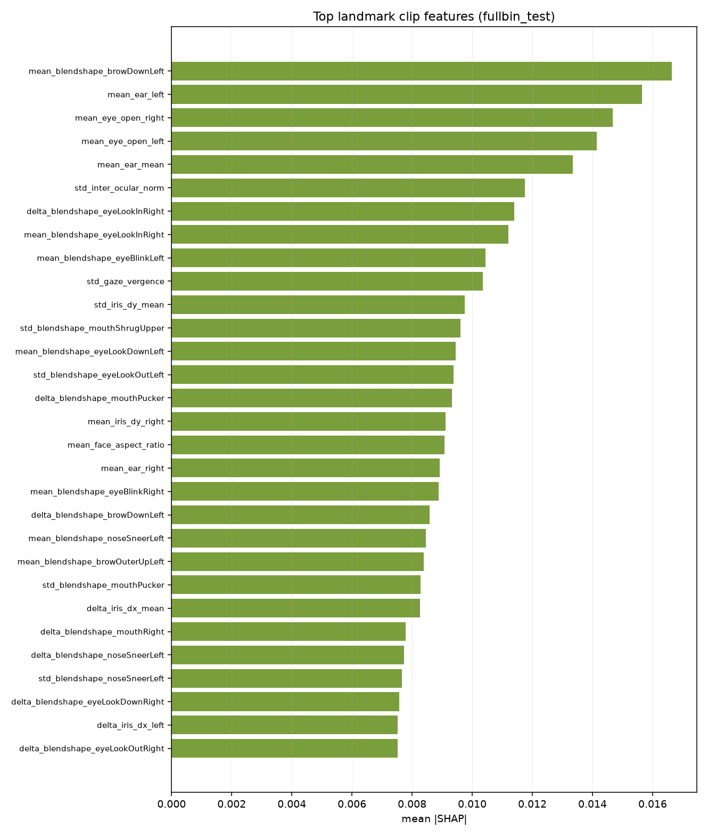
Fig. 7.1 Top named landmark features by mean absolute SHAP value.
Integrated gradients on individual clips corroborate this with a caveat. On three worked examples the landmark branch contributed +2.14, +1.51 and +1.56 to the predicted-class score while the deep branch contributed -0.35, -0.14 and +0.12. Taken with the SHAP result, the consistent reading is that the deep block carries comparable attribution magnitude but does not push consistently toward the correct class, whereas the landmark geometry does.
7.7 Discussion
Three findings follow from the results above, and they are not all favourable to the hypothesis the project set out to test.
- First, the architecture produces a usable disengagement detector. ROC-AUC 0.7943 against a 0.5 no-signal baseline, with average precision 5.3 times its baseline, is a real capability on a dataset where 95% of clips belong to one class.
- Second, the reliability mechanism does not account for it. The controlled ablation puts its contribution at 0.0002 ROC-AUC, and SHAP attributes the discriminative signal to MediaPipe eye and gaze geometry rather than to the reliability-weighted deep representation.
- Third, the four-class formulation is bounded by annotation ambiguity rather than by model capacity. With ROC-AUC 0.5235 separating High from Very High, and those classes comprising 95% of the test split, no decision rule can raise accuracy above the 0.4944 prior.
The project therefore makes no claim to improved accuracy over published work. Its defensible contributions are the reliability-weight collapse finding and its remedy, the length-preserving treatment of reliability as a weight rather than a gate, the controlled ablation that measures the mechanism's contribution rather than asserting it, and the explainability analysis that localises the discriminative signal to specific, interpretable facial features.

8. CONCLUSION
This project set out to test whether treating observation reliability as a length-preserving weight, with the weighting learned rather than asserted, improves engagement recognition from webcam video. It delivered a complete, verified pipeline on the full DAiSEE release and answered the question, although not in the direction anticipated.
8.1 Summary of work
A nine-module pipeline was implemented and covered by 169 automated tests. The official DAiSEE partition is used unchanged with subject disjointness verified programmatically. A five-component Motion Reliability Score is computed exclusively from observation-quality evidence, calibrated on the training split, and combined by weights learned from a uniform initialisation. The score is applied to frame embeddings and to temporal pooling without removing any frame. A MediaPipe geometric branch is fused with the deep temporal branch, and the result is evaluated against explicit baselines and explained with four attribution methods.
8.2 Findings
- As a binary disengagement detector on the full test split the system reaches ROC-AUC 0.7943 against a 0.5 no-signal baseline and average precision 0.2628 against a 0.0493 baseline, recovering 54 of 88 disengaged clips.
- A controlled ablation differing in two of 117 settings measures the contribution of reliability weighting at 0.0002 ROC-AUC. The mechanism does not measurably improve recognition on this dataset.
- Softmax-parameterised component weights collapse onto a single component over a long run. Weight decay, not learning rate, bounds them, because zero in the parameter space is exactly the uniform weighting.
- SHAP over 512 test clips attributes roughly twice the per-dimension influence to eye openness and gaze features as to the entire deep temporal block, and the five highest-ranked features are all eye-related.
- The High versus Very High boundary carries ROC-AUC 0.5235, which bounds four-class accuracy below the majority-class prior irrespective of the decision rule.
8.3 Limitations
- Single-seed results. The full-scale comparisons report one run per configuration. The development-scale ablation showed a seed-to-seed standard deviation of 0.0266 in macro F1, so differences smaller than roughly 0.04 cannot be distinguished without repeated seeds.
- The learned-weight claim is untested rather than refuted. Both ablation arms peaked at epoch 0, by which point the five weights had moved only from 0.200 to between 0.182 and 0.218, so the comparison effectively contrasts uniform weighting against none.
- No comparison against an external published system was run on this protocol. Published DAiSEE figures use varying splits, evaluation granularities and class formulations, and are not directly comparable to the results here.
- DAiSEE participants are adults in e-learning sessions. Nothing in these results transfers to other age groups or recording conditions without re-validation.
8.4 Future work
- Give the learned weights a fair test by freezing the backbone and training on cached features, where an epoch costs seconds rather than minutes. This allows the hundreds of epochs and multiple seeds the five weights need in order to move, and permits a sweep of the decay strength that currently bounds them.
- Exploit the three unused affect labels. DAiSEE annotates boredom, confusion and frustration alongside engagement, and boredom in particular is close to an inverse of the target. Multi-task training would quadruple the supervision available from the same clips at no additional data cost.
- Model the levels as ordinal rather than categorical. Engagement is ordered, and ordinal regression targets adjacent-class boundaries directly, which is where the present model is at chance. It would also yield the mean absolute error, root mean squared error and Pearson correlation reported by comparable work.
- Normalise features within each participant. Engagement is judged relative to an individual's baseline, and subject-level centring is a standard and often substantial gain in affect recognition.
- Given that attribution localises the signal to eye and gaze geometry, evaluate a landmark-only model of a few hundred thousand parameters against the present 87-million-parameter system. If it matches, the simpler model is the better engineering answer.
8.5 Closing remark
The hypothesis this project was built to test was not supported by the evidence it produced. That outcome was established by a controlled experiment rather than inferred from a single score, and it is reported here with the baselines, the effect size and the statistical power stated. A negative result obtained this way is more useful to subsequent work than an unverified positive one, and the reliability-weight collapse found along the way is a defect that will recur in any system parameterising learned mixture weights through a softmax.

9. REFERENCES
[1] A. Gupta, A. D'Cunha, K. Awasthi, and V. Balasubramanian, “DAiSEE: Towards user engagement recognition in the wild,” arXiv:1609.01885, 2016.
[2] J. Whitehill, Z. Serpell, Y.-C. Lin, A. Foster, and J. R. Movellan, “The faces of engagement: Automatic recognition of student engagement from facial expressions,” IEEE Transactions on Affective Computing, vol. 5, no. 1, pp. 86–98, 2014.
[3] O. Sumer, P. Goldberg, S. D'Mello, P. Gerjets, U. Trautwein, and E. Kasneci, “Multimodal engagement analysis from facial videos in the classroom,” IEEE Transactions on Affective Computing, vol. 14, no. 2, pp. 1012–1027, 2023.
[4] J. Donahue, L. A. Hendricks, S. Guadarrama, M. Rohrbach, S. Venugopalan, K. Saenko, and T. Darrell, “Long-term recurrent convolutional networks for visual recognition and description,” in Proc. IEEE CVPR, 2015, pp. 2625–2634.
[5] D. Tran, L. Bourdev, R. Fergus, L. Torresani, and M. Paluri, “Learning spatiotemporal features with 3D convolutional networks,” in Proc. IEEE ICCV, 2015, pp. 4489–4497.
[6] G. Bertasius, H. Wang, and L. Torresani, “Is space-time attention all you need for video understanding?,” in Proc. ICML, 2021, pp. 813–824.
[7] A. Gu and T. Dao, “Mamba: Linear-time sequence modeling with selective state spaces,” arXiv:2312.00752, 2023.
[8] L. Zhu, B. Liao, Q. Zhang, X. Wang, W. Liu, and X. Wang, “Vision Mamba: Efficient visual representation learning with bidirectional state space model,” in Proc. ICML, 2024.
[9] “MC-MIFA: A multi-scale contrastive framework with mutual information for student engagement recognition,” PMC13328615, 2025.
[10] C. Lugaresi, J. Tang, H. Nash, C. McClanahan, E. Uboweja, M. Hays, F. Zhang, C.-L. Chang, M. G. Yong, J. Lee, W.-T. Chang, W. Hua, M. Georg, and M. Grundmann, “MediaPipe: A framework for building perception pipelines,” arXiv:1906.08172, 2019.
[11] A. Ablavatski, A. Vakunov, I. Grishchenko, K. Raveendran, and M. Zhdanovich, “Real-time Pupil Tracking from Monocular Video for Digital Puppetry,” arXiv:2006.11341, 2020.
[12] Y. Kartynnik, A. Ablavatski, I. Grishchenko, and M. Grundmann, “Real-time facial surface geometry from monocular video on mobile GPUs,” in Proc. CVPR Workshops, 2019.
[13] P. Ekman and W. V. Friesen, Facial Action Coding System: A Technique for the Measurement of Facial Movement. Palo Alto, CA: Consulting Psychologists Press, 1978.
[14] T. Soukupová and J. Čech, “Real-time eye blink detection using facial landmarks,” in Proc. 21st Computer Vision Winter Workshop, 2016.
[15] J. L. Pech-Pacheco, G. Cristóbal, J. Chamorro-Martínez, and J. Fernández-Valdivia, “Diatom autofocusing in brightfield microscopy: A comparative study,” in Proc. 15th Int. Conf. Pattern Recognition, 2000, pp. 314–317.
[16] F. Crete, T. Dolmiere, P. Ladret, and M. Nicolas, “The blur effect: Perception and estimation with a new no-reference perceptual blur metric,” in Proc. SPIE Human Vision and Electronic Imaging XII, vol. 6492, 2007.
[17] P. Terhörst, J. N. Kolf, N. Damer, F. Kirchbuchner, and A. Kuijper, “SER-FIQ: Unsupervised estimation of face image quality based on stochastic embedding robustness,” in Proc. IEEE CVPR, 2020, pp. 5651–5660.
[18] A. Kendall and Y. Gal, “What uncertainties do we need in Bayesian deep learning for computer vision?,” in Proc. NeurIPS, 2017, pp. 5574–5584.
[19] J. Yang, P. Ren, D. Zhang, D. Chen, F. Wen, H. Li, and G. Hua, “Neural aggregation network for video face recognition,” in Proc. IEEE CVPR, 2017, pp. 4362–4371.
[20] S. M. Lundberg and S.-I. Lee, “A unified approach to interpreting model predictions,” in Proc. NeurIPS, 2017, pp. 4765–4774.
[21] A. Dosovitskiy, L. Beyer, A. Kolesnikov, D. Weissenborn, X. Zhai, T. Unterthiner, M. Dehghani, M. Minderer, G. Heigold, S. Gelly, J. Uszkoreit, and N. Houlsby, “An image is worth 16x16 words: Transformers for image recognition at scale,” in Proc. ICLR, 2021.
[22] A. Steiner, A. Kolesnikov, X. Zhai, R. Wightman, J. Uszkoreit, and L. Beyer, “How to train your ViT? Data, augmentation, and regularization in vision transformers,” Transactions on Machine Learning Research, 2022.
[23] Y. Cui, M. Jia, T.-Y. Lin, Y. Song, and S. Belongie, “Class-balanced loss based on effective number of samples,” in Proc. IEEE CVPR, 2019, pp. 9268–9277.
[24] V. Bazarevsky, Y. Kartynnik, A. Vakunov, K. Raveendran, and M. Grundmann, “BlazeFace: Sub-millisecond neural face detection on mobile GPUs,” arXiv:1907.05047, 2019.
[25] I. Loshchilov and F. Hutter, “Decoupled weight decay regularization,” in Proc. ICLR, 2019.

Web resources:
DAiSEE dataset - https://people.iith.ac.in/vineethnb/resources/daisee/
Mamba reference implementation - https://github.com/state-spaces/mamba
Vision Mamba (Vim) - https://github.com/hustvl/Vim
MediaPipe Solutions - https://ai.google.dev/edge/mediapipe/solutions/guide
PyTorch Image Models (timm) - https://github.com/huggingface/pytorch-image-models

APPENDIX A - SAMPLE CODE
Four excerpts are reproduced: the reliability combination, the length-preserving weighting, the prior that bounds the learned weights, and the detection metric that makes accuracy legible on an imbalanced split. The complete source is organised as described in section 5.1.
A.1 Combining the five reliability components
COMPONENTS = ("blur", "face_visibility", "head_pose",
"eye_visibility", "motion_consistency")

def mrs_from_arrays(blur_raw, face_area_fraction, detector_confidence,
head_pose_deg, eye_visibility, motion_consistency,
cfg_mrs, calibration):
"""[T] raw arrays -> reliability score [T] in [0, 1]."""
weights = cfg_mrs["weights"]
total_w = sum(float(weights[c]) for c in COMPONENTS)
parts = components_from_arrays(blur_raw, face_area_fraction,
detector_confidence, head_pose_deg,
eye_visibility, motion_consistency,
cfg_mrs, calibration)
mrs = sum(float(weights[c]) * parts[c] for c in COMPONENTS) / total_w
return np.clip(mrs, 0.0, 1.0).astype(np.float32)
A.2 Learned weights as a softmax over five parameters
class LearnableMRSWeights(nn.Module):
"""w = softmax(theta); theta = 0 is exactly the uniform 0.2 weighting,
which is why weight decay on theta is a prior toward uniform."""

def __init__(self, n_components: int = 5):
super().__init__()
self.theta = nn.Parameter(torch.zeros(n_components))

def weights(self) -> torch.Tensor:
return torch.softmax(self.theta, dim=0)

def forward(self, components: torch.Tensor) -> torch.Tensor:
# components [B, T, 5] -> reliability [B, T]
return (components * self.weights()).sum(dim=-1).clamp(0.0, 1.0)
A.3 Reliability as a weight, never as a gate
def forward(self, vit_features, mrs, landmark_features=None,
mrs_components=None):
# Recompute the score from components so the combination is in
# the graph and the five weights receive gradient.
if self.learnable_mrs is not None and mrs_components is not None:
mrs = self.learnable_mrs(mrs_components)

# Scale every frame; drop none. The temporal positions and their
# ordering are preserved, so the state-space model still sees a
# regularly sampled sequence.
weighted = self.mrs_weighting(vit_features, mrs)
sequence, pooled = self.temporal(weighted, mrs)

deep = self.deep_branch(pooled)
land = self.landmark_branch(landmark_features) if self.use_landmarks else None
return self.classifier(self.fusion(deep, land))
A.4 Detection metrics for a 95/5 split
def evaluate_detector(y_true, probs, tune_on=None,
objective="balanced_accuracy"):
"""Accuracy is not the headline here: a constant 'engaged' answer
scores 0.9507 while detecting nothing, so a BETTER detector often
reports a LOWER accuracy. ROC-AUC leads; the operating point is
chosen on validation and applied unchanged to test."""
scores = detection_scores(probs)
out = {"ranking": ranking_metrics(y_true, scores),
"argmax": operating_point(y_true, scores, 0.5)}
if tune_on is not None:
v_true, v_probs = tune_on
chosen = choose_threshold(v_true, detection_scores(v_probs), objective)
out["tuned"] = operating_point(y_true, scores, chosen["threshold"])
out["tuned"]["threshold_chosen_on"] = "validation split"
return out

